
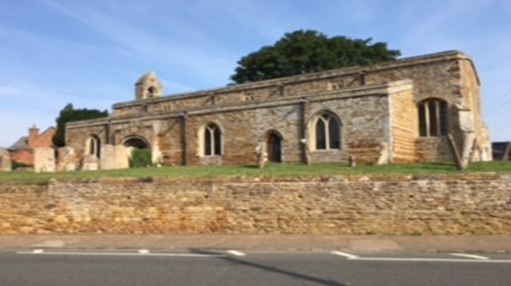
St Mary the Virgin, Little Harrowden
Parish Profile
Mission Statement
- To be an active part of our Benefice, working together to bring Christ’s message to our communities
- To make our church a warm, welcoming, inclusive and welcoming place for all making safeguarding our priority
- To look forward, making changes as needed so that we accommodate all people in every walk of life

Growth Action Plan

Our past year Growth Action Plan
What we did not achieve:
- We were only able to pay 42% of our Parish Share
- We were not successful in our Stewardship campaign and were unable to increase our Parish Giving.

Growth Action Plan for 2026
- To increase the amount of Parish Share we give by at least another 10% of the amount paid this year by supporting the work of the Social Committee in raising much needed funds
- To continue to support Children’s Church i.e. Breakfast Church, Youth Group and Little Lights
- To increase attendance to our weekly Coffee Mornings, Men’s Breakfast and Knit & Natter
- To invite people to become involved with church activities
- To continue to be a warm and welcoming church

Five Year Growth Action Plan
- To increase the amount we pay of our Parish Share by encouraging the congregation to increase their giving via the Parish Giving Scheme or direct debit
- To set up a Pastoral Care Team as an outreach to include Communion to the housebound
- To continue to hold Annual services that bring non-church people in, such as All Souls Quiet and Reflection, Remembrance Service. Christingle & Crib Service.
- To continue our advertising of events and services with eye-catching posters and advertising on Social Media as well as word of mouth and direct invitations
- To continue with our outreach plans to promote the Church’s mission as well as the vision and values of the Church. Also to nurture our faith within the Church and engaging the wider community
- To continue to support our Heritage Trust
Our Church of St Mary the Virgin
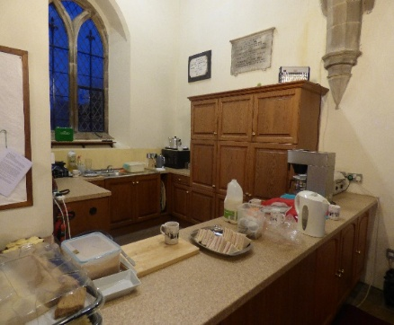
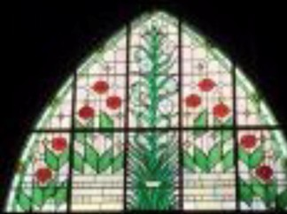
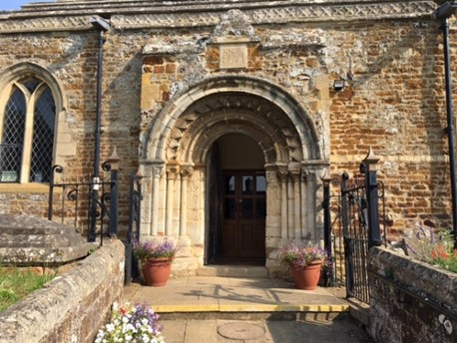
The Church is a Grade II* listed stone building. There is an oak screen War Memorial which denotes the names of the men of Great and Little Harrowden who were killed in both World Wars. The fanlight above the screen is now the position of the memorial window and dedicated in October 2010 by Bishop Donald Allister.
The Main Churchyard is closed whilst the new Churchyard to the rear of the Church has a few remaining burial and ashes plots. Over the last few years, we’ve tried to make this churchyard wildlife friendly, with a bug hotel, bird boxes whilst planting bulbs and flowers. There is now a bench making it a place to sit and reflect.

Quinquennial Report
The last Quinquennial Inspection was carried out in 2018 and most items highlighted have been carried out. Our Heritage Trust is financing our Quinquennial Inspection this year.
This registered Charitable Trust comprises of a committee of residents that raise funds exclusively for the fabric of our Church. This has ensured that the building is structurally sound and in good order, installing such things as modern heating, lighting, sound system and alarm system.

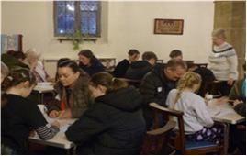
Our Church is warm and welcoming and is frequently used for church meetings and events and as such is a valuable resource especially as we have the bonus of a kitchen area in church as well as a toilet with a baby changing facility.

We feel that the events we hold are especially aimed at community outreach. These being a Community Coffee Morning once a week, a fortnightly Knit and Natter group, monthly Men’s Breakfast, and a monthly Youth Group. We hope to re-instate the fortnightly Toddler Group, Little Lights, when the leader finishes maternity leave.
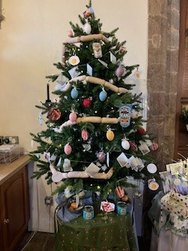
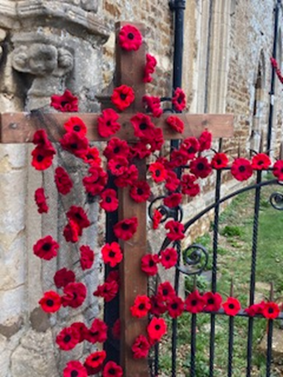
We have a Social Committee who organise the social and fund-raising activities raising approximately £6000 a year which contributes towards our Parish Share. We also raise monies for other charities with our Lent lunches and Christingle.

Our Strengths
- We have a strong lay team so we can have more than one Sunday service a month eg Breakfast Church
- Our Youth Group is growing
- We have a strong Social Committee planning community events as outreach
- We have good facilities of a kitchen area, toilet and heating

Our Challenges
- Paying our Parish Share
- Getting Little Harrowden Community into Church

Our Village

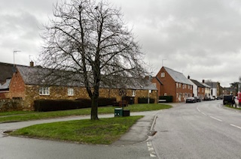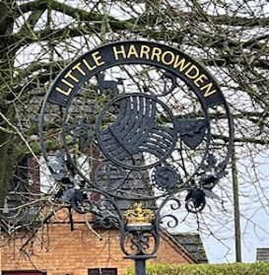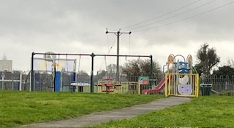
Little Harrowden Parish is one of the longest and narrowest in Northamptonshire and is built around the Church of St Mary the Virgin, which dates to circa 1190. The parish’s population in the 2021 census was 973. The village itself is a typical linear village without a defined centre. Over the last thirty years all the shops have been closed as well as the two public houses.

Building developments include 2 local authority estates built in the
of which many are now privately owned, a large private estate built in the 1970s and a couple of new private developments built on brown fill land. There are several Victorian terraced railway cottages with a small industrial estate nearby.

The local primary school, next to the church, was established approximately 350 years ago and changed to academy status in 2018. Currently its roll is 189 of which a high proportion comes from Wellingborough and the surrounding area. They use the church only for their carol service. Ties have been lost but we hope that these will be re-established.

The Village Hall is active and has many clubs and functions on a regular basis such as keep fit, indoor bowls, the venue for the Parish Council meetings and private parties. This year they have created a weekly “warm space” day providing soup for lunch and cakes for afternoon tea.
The Working Men’s Club is extremely popular and has regular entertainment with teams competing in local leagues at pool, skittles, crib and bar billiards.

Finance

Since 2018 our congregation attendance has slowly declined through deaths and families re-locating. This has had an adverse effect on our income as our numbers have diminished. We have not been able to meet our full quota of the Parish Share since then despite Fund Raising efforts.

Although these events have been well attended, we are only able to raise approximately £6,000 per annum.
We do look on our Fund-Raising Events as an outreach as well as for financial gain. We are well supported by a strong core of the community,

Although our funds are low, we have been able to maintain the Church building in good repair and maintenance.

Our aim is to increase our Parish Share giving each year until we are able to pay in full.

